Map editor:

The map editor can enable user to add or delete block in the level files by interface.

User can add block if they pick up block first and then click at the position they want to place the block at. After user picked up a block, the cursor will turn to be a “+” to indicate that a block has been picked, and if user choose delete, cursor will be like “X”.

User can scroll the map if it is too long by scroll left button and scroll right button in the surface and it appears like ”<<<” and ”>>>”, scroll button will not immediately changed the screen ,but act like a player to focus on the game.

After editing, the users should preserve the map edited by pressing the button “:save&quit”.

A button called “map editor“ is added to menu. When clicked, it will pop up a window for user to choose between “create level” to create a new level or “edit level” to edit existed level file.

If user choose create new. They should enter the name, height and width of the new level. After that, click “next” to enter map editor.

Else if they choose “ edit level”, they need to choose the file they want to edit. After the, they will enter map editor.

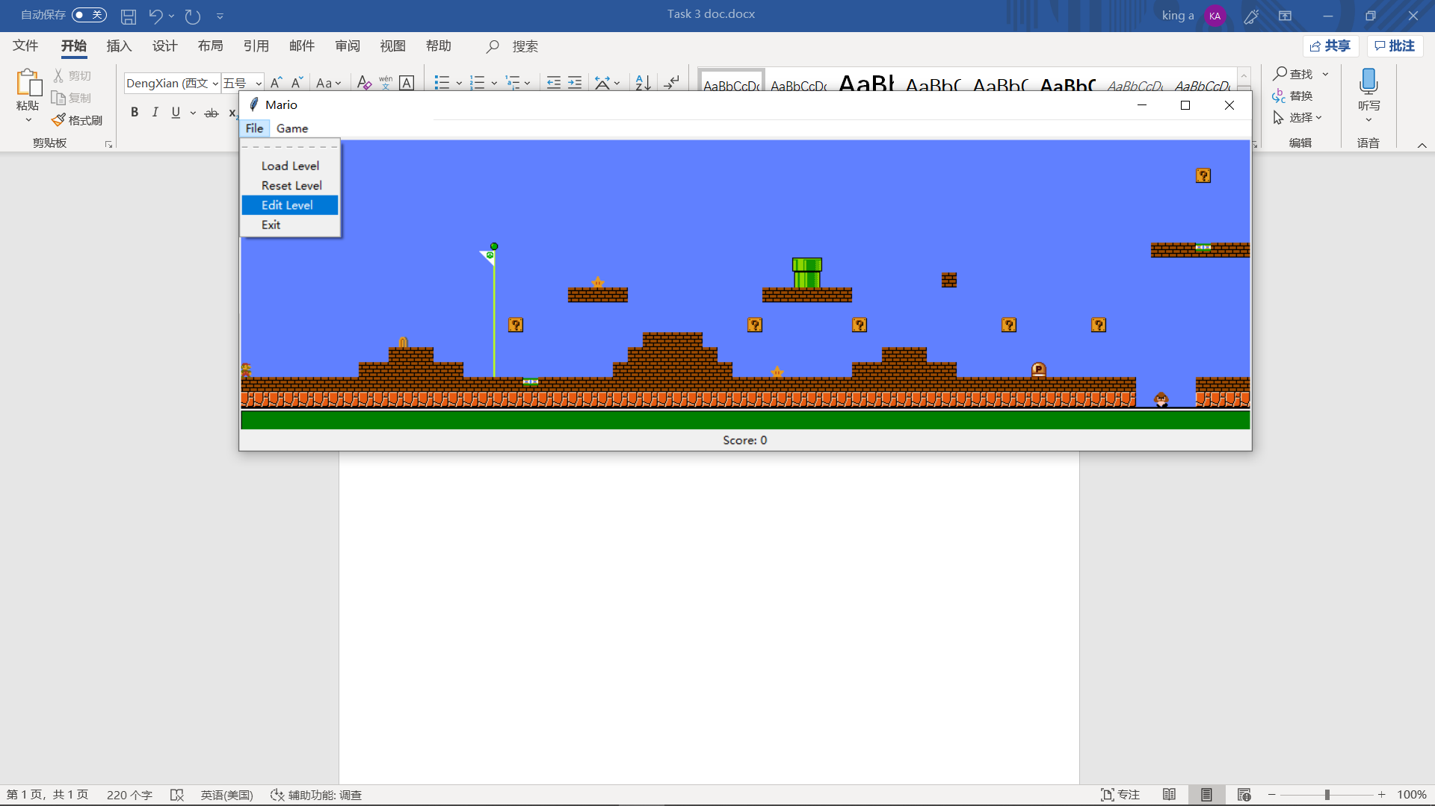

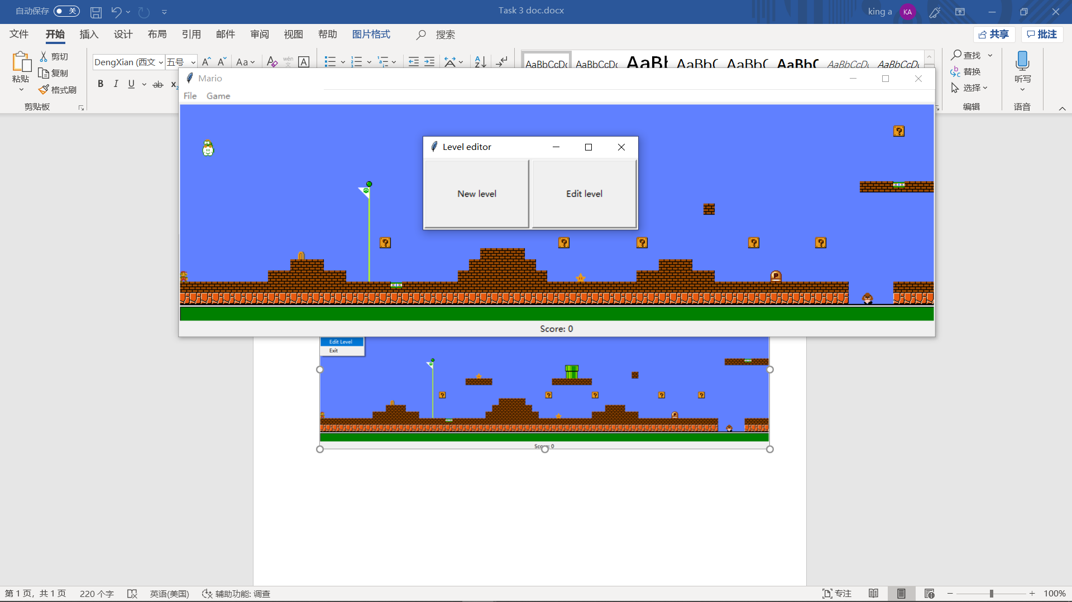

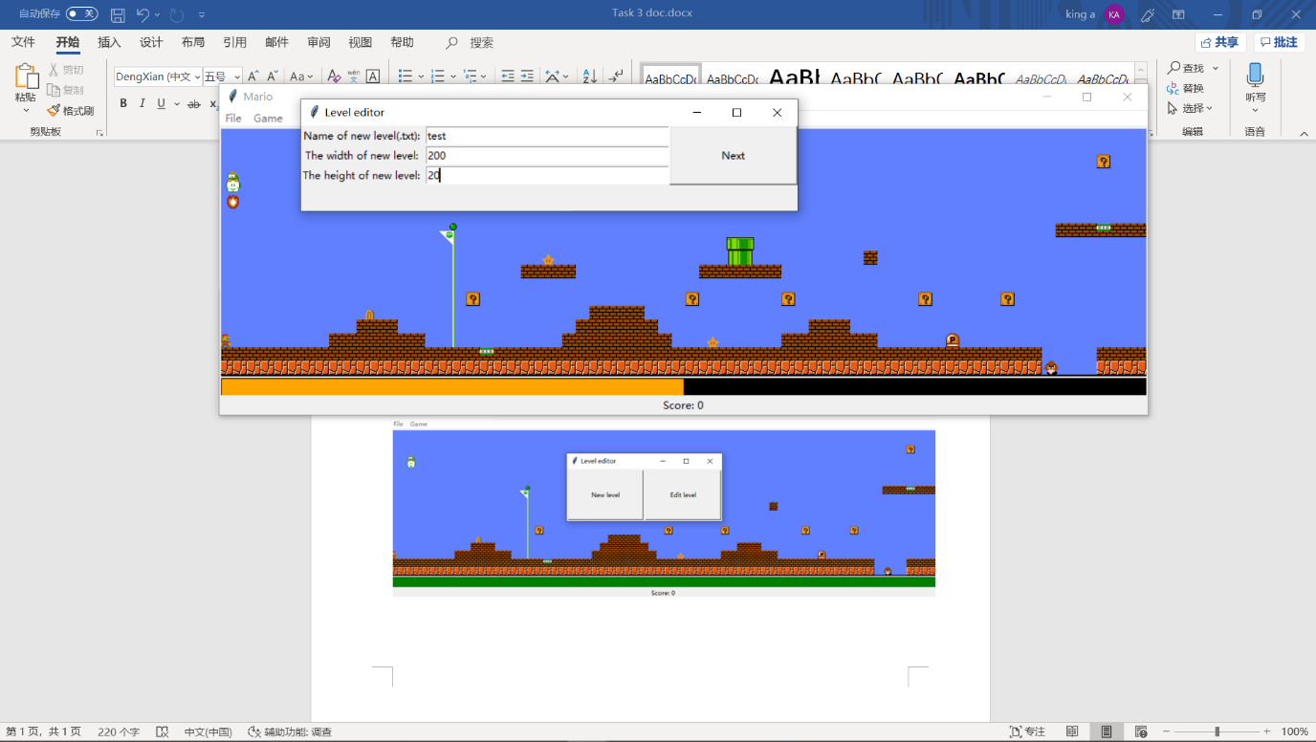

Prompt user enter basic date for a map

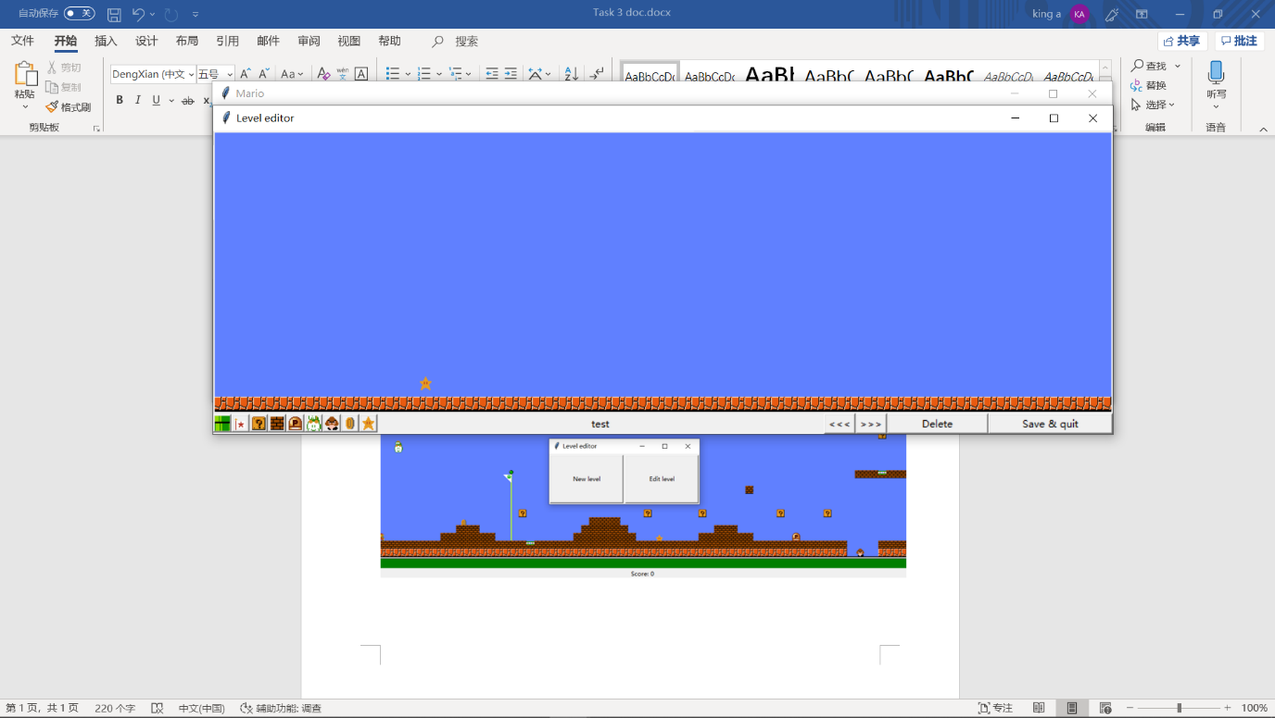

A star is added to the map by button to the left on the bottom.

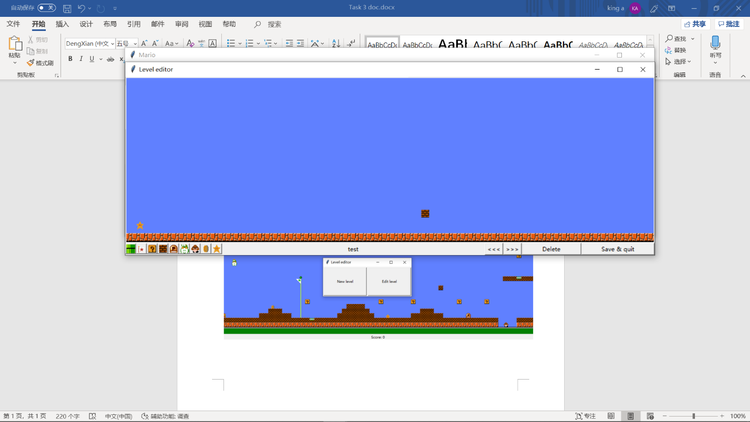

A brick is added to the map after scroll.

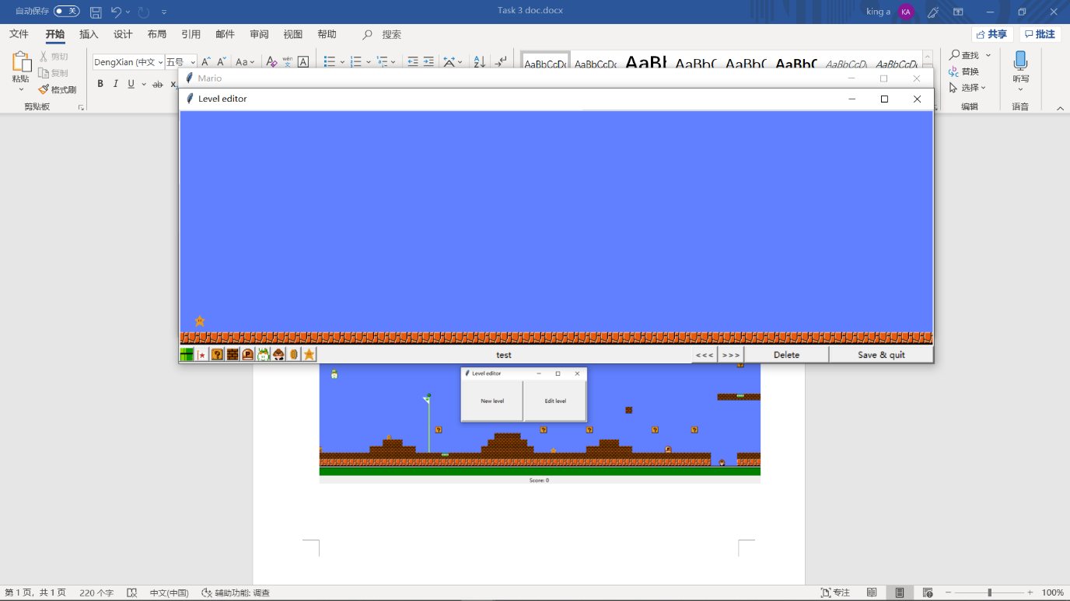

The brick is deletede using ”delete”

Cursor change can not be shown due to windows screenshot.